|  |  |  |  |  |  |
| --- | --- | --- | --- | --- | --- |
|  |  | | |  | |
|  |  | **AMERICAN INTERNATIONAL UNIVERSITY – BANGLADESH**  **Faculty of Engineering** | | | |
| **Course/Lab Name**: | | | Data Communication | | |
| **Semester: Spring** 2023-24 | | | | **Term**: Mid | **Assignment-1** |

**Question Mapping with Course Outcomes:**

|  |  |  |  |  |  |  |  |
| --- | --- | --- | --- | --- | --- | --- | --- |
| **Item** | **COs** | **POIs** | **K** | **P** | **A** | **Marks** | **Obtained Marks** |
| **All Problems** | **CO3** | **P.c.3.C5** | **K5** | **.** | **.** | **30** |  |
| **Total:** | | | | | | **30** |  |

**Student Information:**

|  |  |  |  |
| --- | --- | --- | --- |
| **Student Name:** | **MD. ABU TOWSIF** | **Student ID:**  **22-47019-1** |  |
| **Section: H** |  | **Department:** | **CSE** |

**Instructions for submission:**

1. Use this page as a cover page.

2. Take pictures of your written answer and paste under each problem given below.

3. Give the file name using the middle 5 digits of your student ID.

For instance: if your ID is 20-40708-3 your file name will be 40708.pdf

4. Upload the pdf file to MS Teams portal.

5. The submission will not be considered if the instructions are not followed.

**Answer the following Questions:**

**Problem 01**: Why baseline wandering, DC component and lack of synchronization is a problem in digital data to digital signal representation, explain with necessary figures.

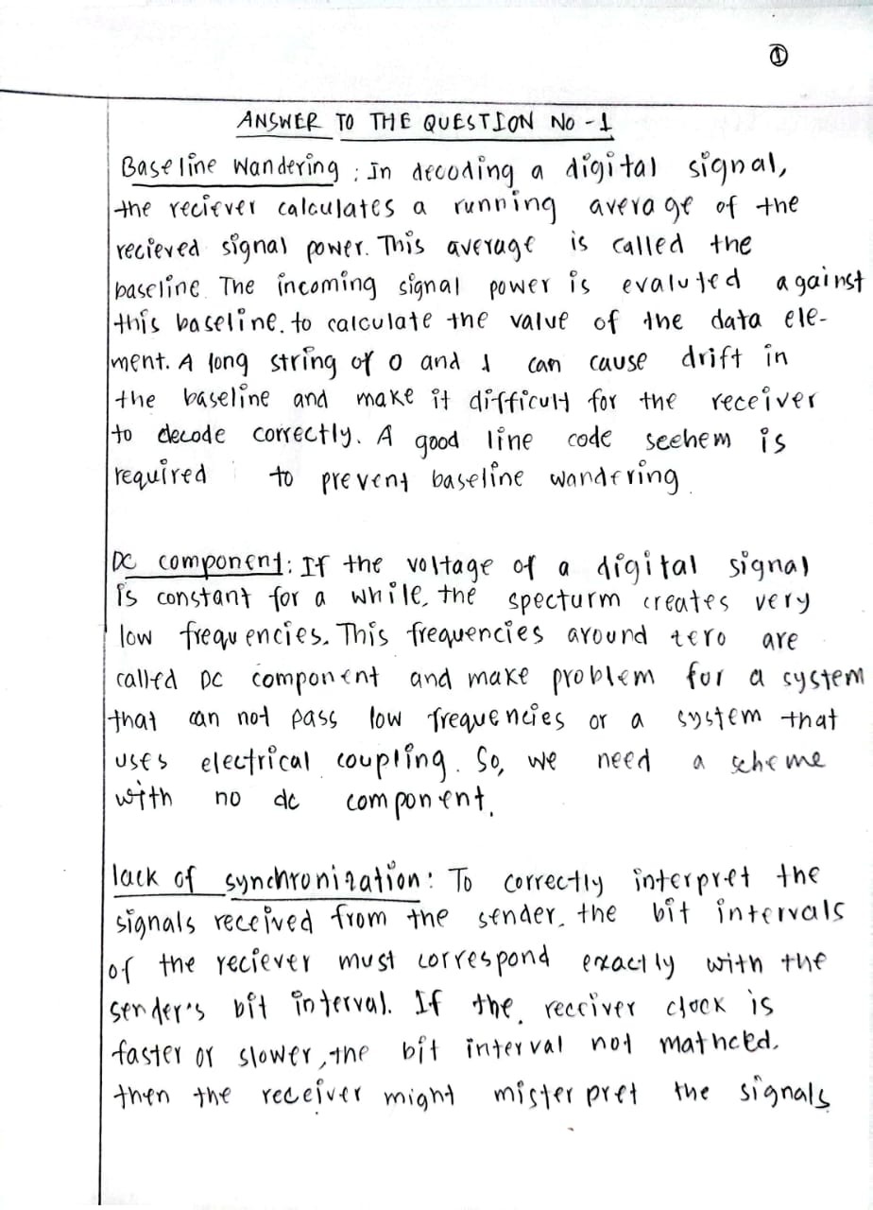**Answer:**

**Problem 02**: Draw the graph of the NRZ-L for the bit stream 01010111, assuming that the last signal level has been positive.

**Answer:**

**Problem 03**: Repeat problem 02 for NRZ-I.

**Answer:**

**Problem 04**: Repeat problem 02 for Manchester and Differential Manchester.

**Answer:**

**Problem 05**: Encode digital bit stream 01001101 using AMI and Pseudoternary.

**Answer:**

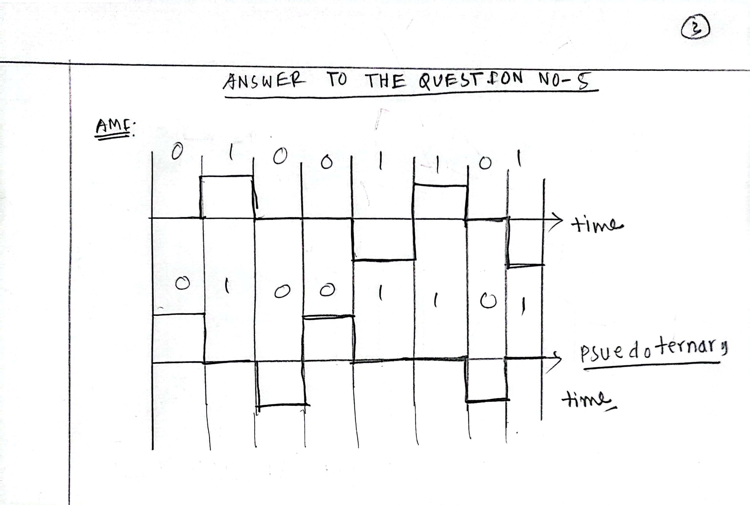

**Problem 06:** Encode digital bit stream 0011001100110011 by using 2B1Q by assuming last signal level was positive and consider the voltage level for each bit stream pair according to following table:

|  |  |  |
| --- | --- | --- |
|  | **Previous level positive** | **Previous level negative** |
| **Bit stream pair** | **Next level** | **Next level** |
| 00 | +2 | -2 |
| 01 | +4 | -4 |
| 10 | -2 | 2 |
| 11 | -4 | 4 |

**Answer:**

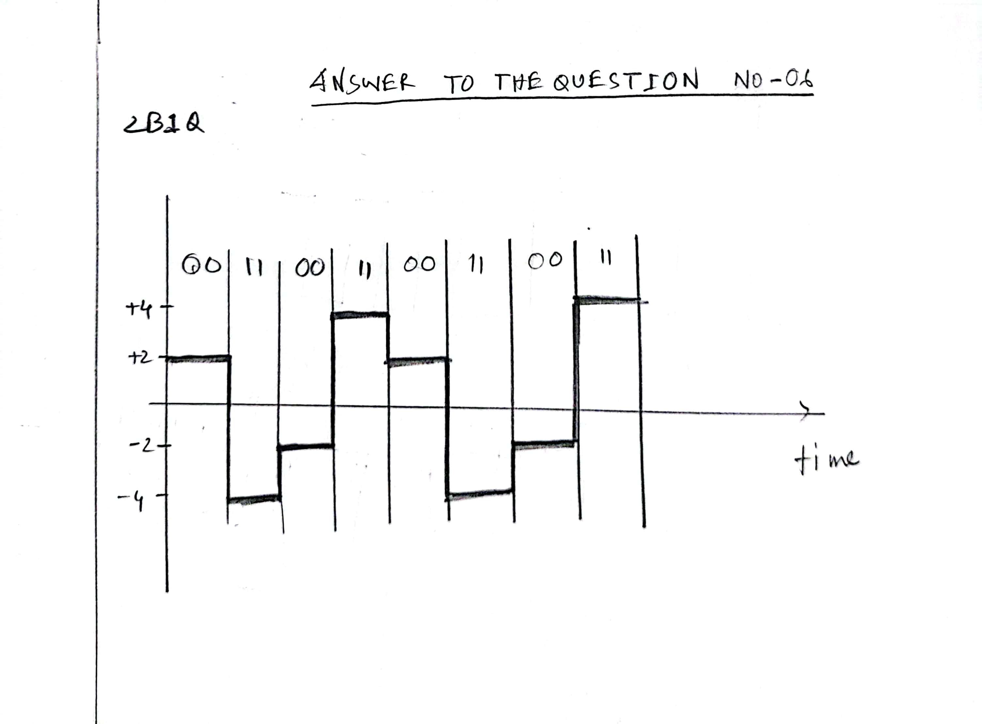

**Problem 08**: Determine the combination of data element and signal element in 8B6T line coding method. Write the possible use cases of remaining signal element in 8B6T.

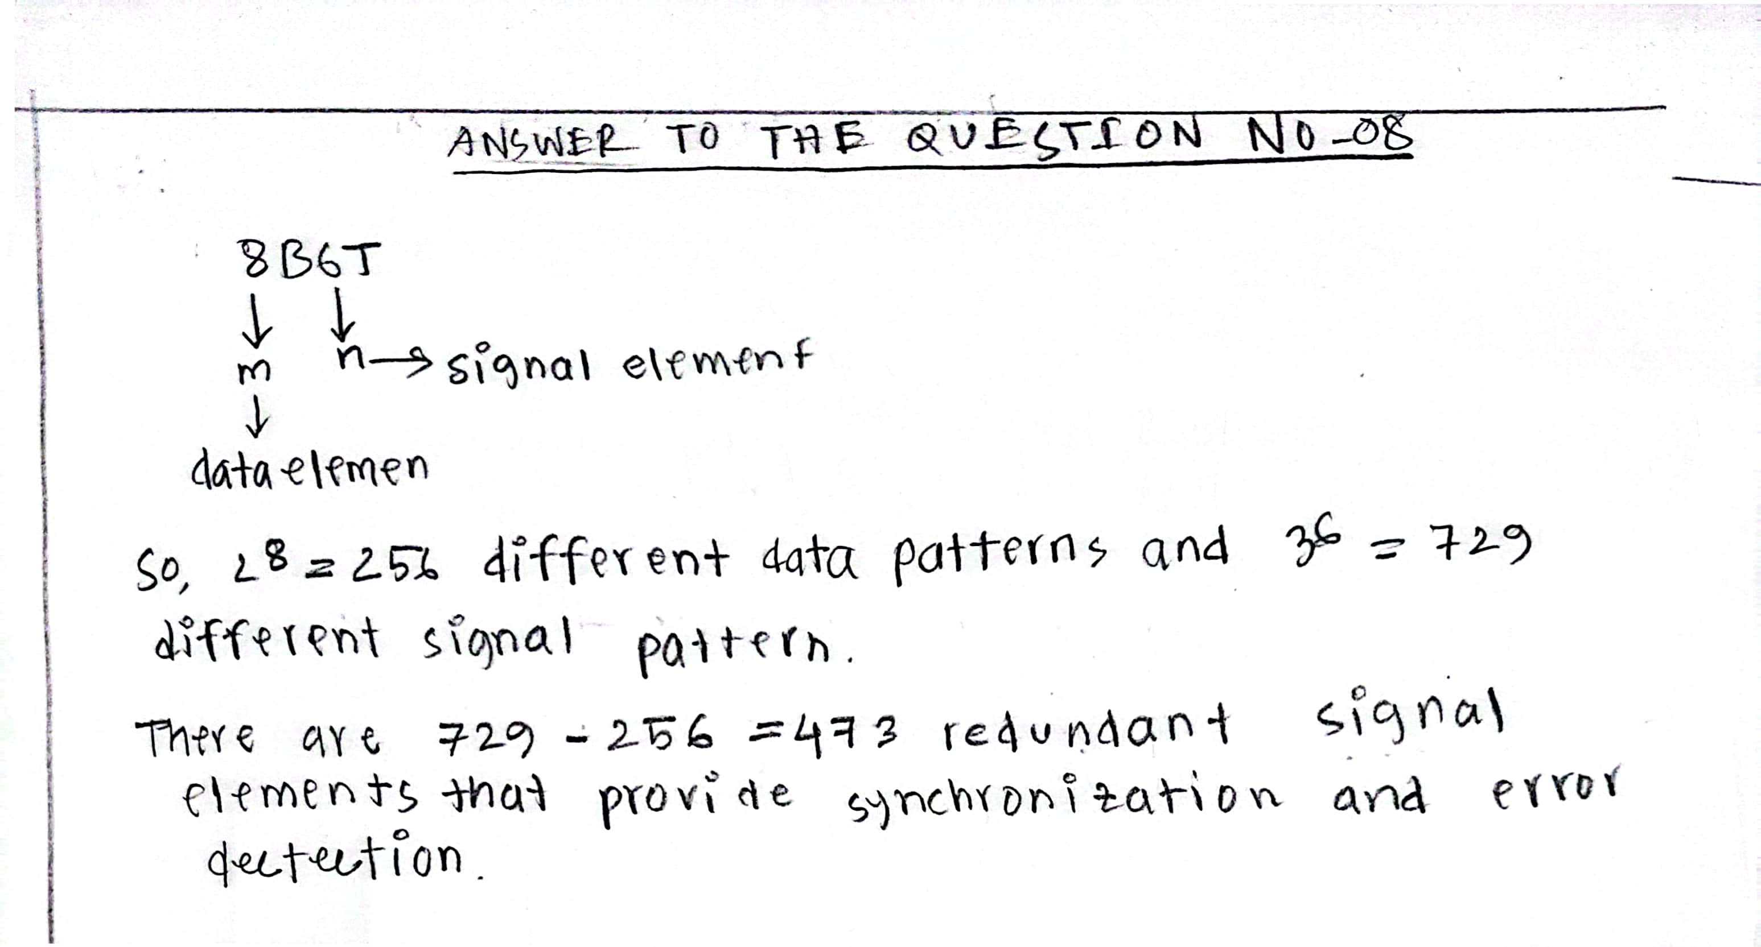**Answer:**

**Problem 09:** Sketch the line coding sequence using 8B6T for following data and signal pattern:

|  |  |
| --- | --- |
| **Data pattern in Hexa Decimal/binary** | **Signal pattern** |
| 2A (00101010) | +0+-0- |
| 6D (01101101) | ++0+-- |
| 6C (01101100) | 0++--+ |

**Answer:**

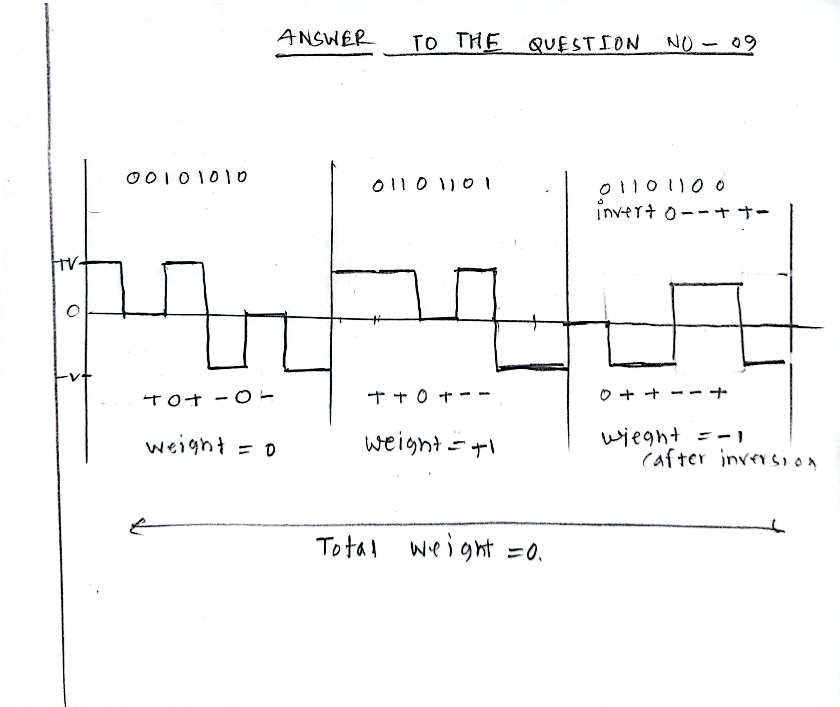

**Problem 10**: Encode digital bit steam 01101011 by using MLT-3 (**Note:** Assume last level was at 0 voltage and last non-zero pulse was negative).

**Answer:**

